Physical Optics Design and Simulation Final Project

Polarizing Properties of Sub-Wavelength Gratings

Marc Lata

OPTI 8206

5/3/2019

# Table of Contents

1 Table of Contents 2

2 Introduction 3

2.1 Polarization & Anisotropy 3

2.2 Sub-Wavelength Gratings & Form Birefringence 5

3 1-Dimensional Subwavelength Grating 6

3.1 TE Anti-Reflective Coating 7

3.2 Subwavelength Grating Quarter Waveplate 9

3.3 Subwavelength Grating Half Waveplate 12

4 2-Dimensional Sub-Wavelength Gratings 14

4.1 2-Dimensional Anti-Reflective Grating 14

4.2 2-Dimensional Grating Quarter Waveplate 17

4.3 2-Dimensional Grating Half Waveplate 19

5 Slanted Gratings 21

5.1 1-DIMENSIONAL SLANTED SUB-WAVELENGTH GRATINGS 21

5.2 Slanted 2-Dimensional Sub-Wavelength Gratings 24

6 Conclusions 27

7 Appendix 28

7.1 Snippets 28

7.1.1 Phase Detector 28

7.1.2 Symmetric 2-Dimensional Grating 29

7.1.3 Slanted Wires Grating 29

8 Works Cited 30

# Introduction

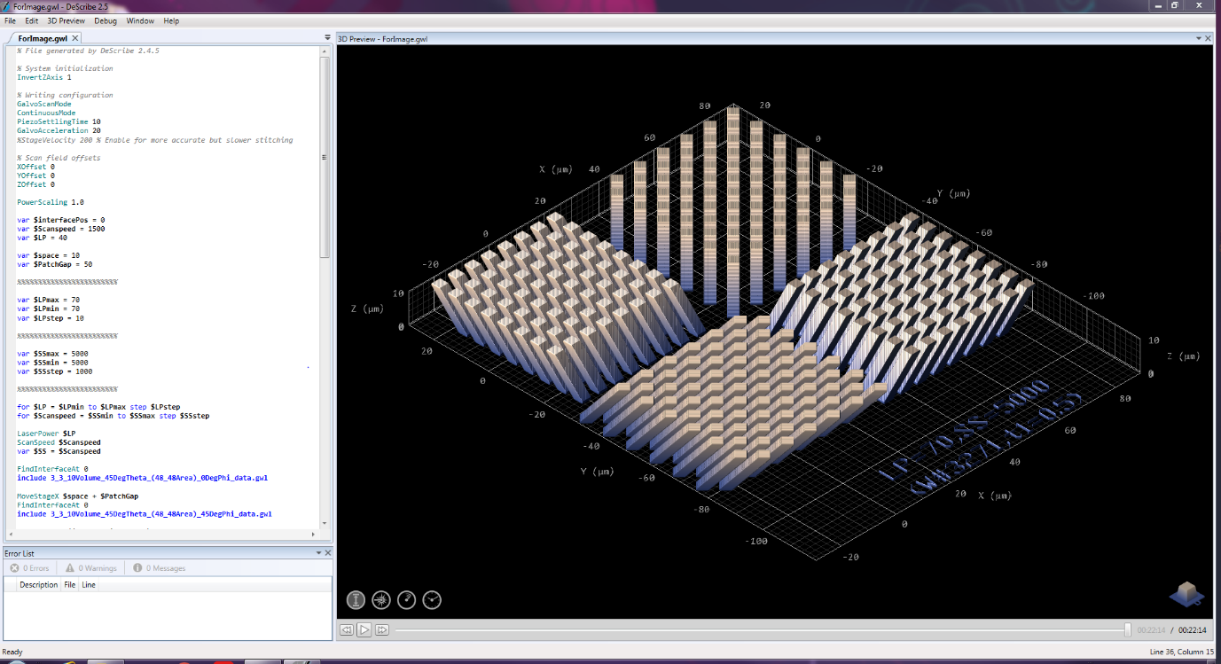My current research project focuses on infrared Mueller matrix imaging of dielectric metamaterial structures fabricated using two-photon lithography. These structures, pictured in Figure 1, are of interest to us because they are relatively straight-forward to fabricate with two-photon lithography, and they are known to have an anisotropic response, which will allow for us to test the response of our Mueller matrix microscope to anisotropic structures. However, in order for these structures to be true test structures, we must have some knowledge of what the expected response is. While it is obvious from their structure that they will have some inherent anisotropy, it is not trivial to predict what response we should expect from them when we put them under the microscope. While these structures can be described as a “Slanted Wire” metamaterial structures, which is how I have gotten in the habit of describing them, they could just as easily be described as a slanted 2-dimensional sub-wavelength grating. From this perspective, I can utilize the well-established body of knowledge surrounding the study of form birefringence in sub-wavelength gratings to analyze the responses of these structures. By analyzing the polarizing properties of first 1-dimensional sub-wavelength gratings, then 2-dimensional sub-wavelength gratings in both theory and through simulations, I will attempt to develop aa better understanding of the response we should expect from these slanted wire structures, and determine what benefit the slanted geometry provides compared to a more traditional grating structure.

Figure : Slanted Wire Metamaterial Structures

## Polarization & Anisotropy

Before I analyze the polarization response of these various sub-wavelength structures, let me first take a moment to outline the relevant aspects of the theory of polarization. Polarization a fundamental property of light that arises from the transverse nature of the electromagnetic waves that make up light.

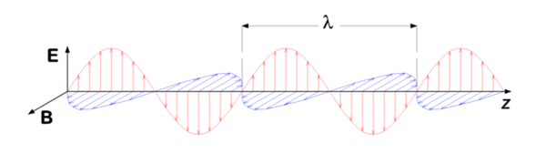

Figure : Illustration of Electric and Magnetic Fields as the Propagate in a Wave [4]

As a light wave propagates, the directions of the electric field, magnetic field, and propagation define a right-handed orthogonal coordinate system. For a given direction of propagation, the electric and 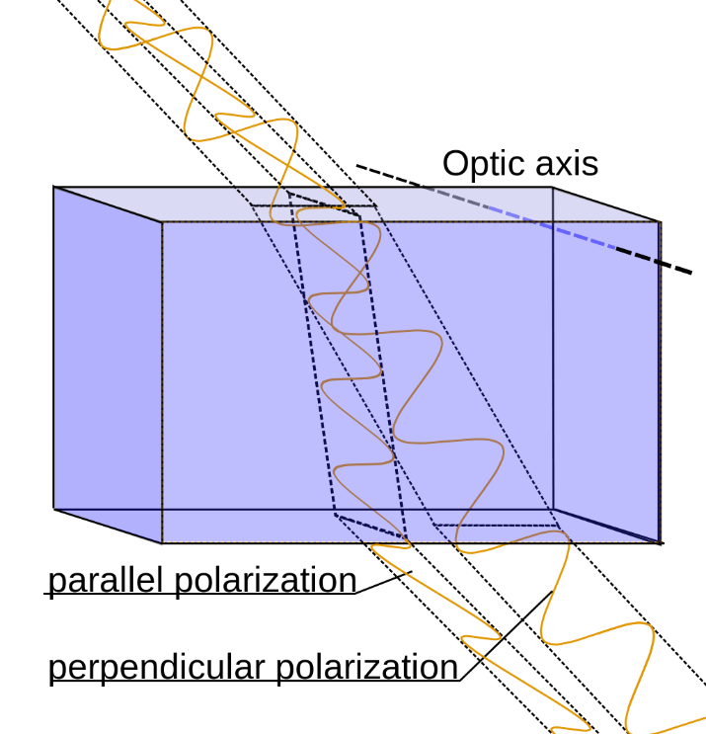magnetic field directions can be anywhere in the plane normal to the direction of propagation while remaining normal to one another. These various directions of the electric and magnetic field constitute different linear polarization states of the light wave, with the direction of polarization traditionally being defined as the direction of the electric field.

Figure : Illustration of Birefringence in Anisotropic Material [1]

When light interacts with a medium, its response will depend on the electromagnetic properties of that material. The most important property to determine this response is the index of refraction, n, which for non-magnetic materials will be equal to the square root of the dielectric permittivity of the material, ɛ­r. This will determine the speed of light in the material, which determines, according to Snell’s Law, the angle of refraction when moving between mediums. For most materials, the relative permittivity and, thus, index of refraction is independent of direction. Materials like this called “isotropic”. However, there are materials for which the permittivity depends on the how the field is oriented with respect to some internal coordinate system of the medium. Materials like this are called “anisotropic”. In general, the permittivity of a material can be represented as a 3x3 tensor of the form:

However, this can always be transformed into a natural coordinate system where this tensor is diagonal, of the form:

Equation : Permittivity Tensor

An isotropic material, then, is one in which . There are also two different types of anisotropic materials: Uniaxial () and Biaxial (). Anisotropy leads to a polarization dependence of the refraction of light, which is most clearly illustrated by the phenomenon of Birefringence, or double refraction. Birefringence occurs when light is incident on an anisotropic material. If the polarization of this light is not aligned with one of the material’s internal optical axes, the projected components of this light’s polarization state onto the internal optical axes will experience different refractive indexes and will thus travel along two separate paths through the medium. This is shown in Figure 3. The fact that light of different polarizations experience different refractive indexes in these materials can be taken advantage of to either filter out light of a given polarization, as is done in devices such as Nicol and Glan-Thompson prisms, or for introducing a specific phase between the two polarizations, as is done in Half- and Quarter-Waveplates.

## Sub-Wavelength Gratings & Form Birefringence

Sub-Wavelength gratings are, as the name suggests, diffraction gratings with periodicities smaller than the wavelength of light they are designed to be used with, as is illustrated in Figure 4:

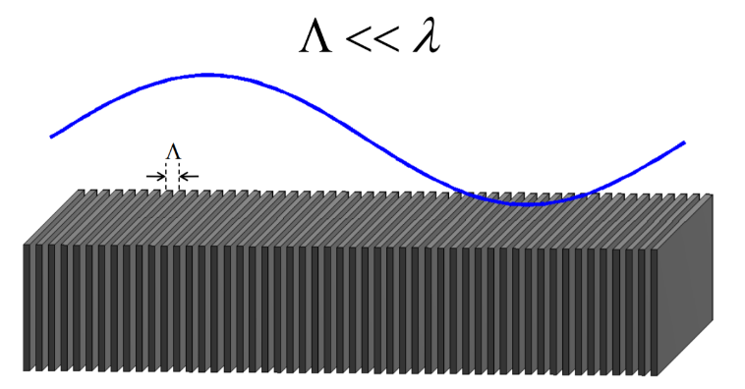

Figure : Illustration of Sub-Wavelength Grating [5]

A traditional grating analysis of such a structure, using the traditional grating equation, suggests that we should see diffraction orders at angles given by:

Equation : Grating Equation

However, it’s clear from this equation that, in the subwavelength limit, because , the angles of All non-zero orders become complex. This means we only obtain a zeroth diffraction order. However, this does not mean that the beam simply passes through undisturbed. In fact, because the wavelength is much larger than the grating size, the light sees that grating, which consists of some defined ratio of a base material and air, as an “Effective Medium” with an index of refraction that is essentially a weighted average of the indexes of these two materials. Further, because the diffraction grating has two clearly defined possible planes of incidence, normal to the grating and parallel to the grating. These two planes of incidence will appear quite different from the perspective of the light and will, in general, have different indexes of refraction. This means a 1-Dimensional subwavelength grating acts as a Uniaxial crystal, with optical axis oriented normal to the surface of the grating. This means that Subwavelength gratings can be used to create optical components that naturally occurring uniaxial crystals have 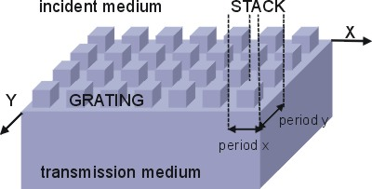traditionally been used for, such as waveplates and polarizers. This phenomenon, where the structure of the material is defining polarization properties, is called Form Birefringence. Additionally, by making this a 2-Dimensional Subwavelength grating, such as the grating illustrated in Figure 5, I can eliminate this asymmetry and create an isotropic effective medium, which is useful for applications where we do not want any polarization dependence, such as antireflection coatings. An asymmetric 2-dimensional grating also allows for independent tuning of the index experienced by both polarization states.

Figure : 2-Dimensional Grating [3]

From this perspective, we can look at the slanted wire structures I have been studying as a symmetric 2-didmensional grating that has been tilted. The symmetric 2-dimensiona crystal, as I just stated, can, through this effective medium approach, be understood as a Uniaxial crystal. So, the Slanted Wire structure might be best understood as a uniaxial crystal with the optic axis tilted away from the normal.

In order to demonstrate and explore the polarizing effects of these various subwavelength gratings, I will perform simulations to demonstrate the ideas introduced here. Through simulation, I hope to ultimately test the notion that the slanted wire can be understood as a tilted uniaxial crystal.

# 1-Dimensional Subwavelength Grating

I’ll start my analyses by looking at the simplest structure that I am interested in, a 1-Dimensional Subwavelength grating. For such a structure, with period and fill factor f and constructed of a material with permittivity in a medium with permittivity , the effective permittivities of the TE and TM modes (transverse to the grating vector direction) can be approximated to second order as:

Equation : Second Order Effective Permitivities of 1-Dimensional Subwavelength Grating [2]

Where the zeroth order permittivities are given by:

Equation : Zeroth Order Effective Permitivities of 1-Dimensional Subwavelength Grating [2]

The index, for non-magnetic materials, will just be given by the square root of the permittivity.

## TE Anti-Reflective Coating

The most direct demonstration of this effective permittivity is through the design of an anti-reflective coating. A perfect AR coating has the following parameters:

Equation : Perfect AR Coating Parameters [6]

Using the effective permittivities described above, we can create an effective medium layer using a subwavelength grating that has exactly these parameters, giving us a perfect AR coating that might be difficult to achieve using any extant coating materials. However, since the index of a 1-D grating is necessarily polarization dependent, we can only achieve these desired parameters for one of the polarization modes. Here, I will present the design of a 1-Dimensional AR grating for the TE mode. To do this, I must determine the grating geometry that will give me the desired film index as described in Equation 5. Since my research involves the use of an FTIR microscope with a spectral range from ~ 2-25 µm, I will use 25 µm as the design wavelength for these structures. In order to be considered subwavelength, then, my gating structures then must have a periodicity of at most:

Equation : Subwavelength Condition [6]

The resin that I am using to print these structures has an index of roughly 1.5 across the infrared spectrum, and they will be immersed in air, which of course has an index of 1. Given, these parameters, the periodicity should be no more than:

In order to make these gratings comfortably subwavelength, as well as to allow for subwavelength response for same of the shorter wavelength’s in my microscope’s spectral range, I will use a periodicity of:

Using these parameters and Equation 3, I can now solve for the fill factor that will give me the desired index for the TE mode. Using [this](https://studentuncc-my.sharepoint.com/:x:/g/personal/mlata_uncc_edu/EcwIpuLhXlZMtJ_QikDI0hMBv5RaD9SCsOHOGHm6xgQyug?e=890Wvp) spreadsheet, I can very easily solve for the desired fill factor. Doing this, I find the fill factor is:

Given this, the width my features should be:

Finally, I must determine the height of the grating. This is given by the AR coating parameters of Equation 5 as:

I can now construct this grating in VirtualLab. To do this, I will use a Rectangular Grating Optical Setup:

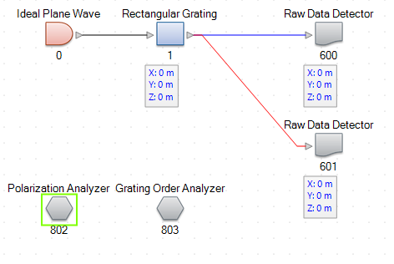

Figure : Rectangular Grating Optical Setup

Notice that I have included the polarization analyzer, which we can use to determine the efficiency for each polarization mode. Let me now program the parameters we determined above. First, I will define the base medium to be a dispersionless material of index 1.5:

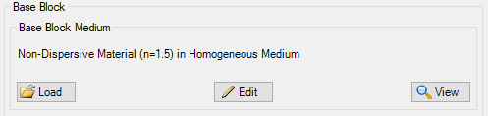

Figure : 1-Dimensional Grating Material

Next, I’ll program the stack on the first surface to use the parameters I’ve described here:

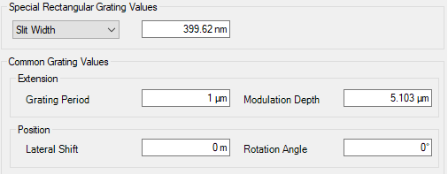

Figure : 1-Dimensional AR Grating Parameters

Finally, I’ll make sure to select “First Stack Only” from the tools menu. Running the Polarization Analyzer detector with this grating gives me the following results:



The Ey direction Corresponds to the TE mode, so our grating design appears to have worked very well! You’ll notice, though, that the TM mode does not have the same perfect AR behavior since the index for this mode is different. We can attempt to optimize both modes using the parametric optimization function in VirtualLab. Unfortunately, though, when I try to do this, I find that VirtualLab is unable to find a solution that optimizes both polarization Modes. To get around this, I can use a 2-Dimensional grating, which I do in section 4.1. While We are not able to make a polarization independent AR coating due to the necessarily different refractive indices of the two modes, we can take advantage of this difference to introduce a fixed phase difference between the two modes, creating either a quarter or half waveplate depending on how much phase is introduced.

## Subwavelength Grating Quarter Waveplate

In order to create a quarter waveplate, I want the phase of each mode to have a difference of:

Equation : Quarter Waveplate Condition

The phase difference between the two modes should be a “Quarter Wave”, which is radians of phase. The phase introduced by plate with index n and thickness d will be given by:

So I can rewrite the Equation 7 as:

This can be rearranged to give:

Equation : Quarter Waveplate Thickness Requirement

Now, since I can determine the expected index of the TE and TM modes using Equation 3, I can determine the thickness needed to create a quarter waveplate. In order to keep this from becoming too thick, though, I want the difference in indices to be as large as possible. Once again, using [this](https://studentuncc-my.sharepoint.com/:x:/g/personal/mlata_uncc_edu/EcwIpuLhXlZMtJ_QikDI0hMBv5RaD9SCsOHOGHm6xgQyug?e=890Wvp) spreadsheet, I can solve for the fill factor that gives us the maximum difference between the two indices. Doing this, I find a fill factor of:

Which gives me an index difference of:

This means that my grating must have a thickness of:

I can now program this into VirtualLab. I’ll input these parameters using the same procedure from Section 3.1. In addition, though, to make sure that I have equal intensity in each polarization mode, I will rotate the polarization to 45°. I also don’t want to see the field immediately at the surface of the grating, so I will move the detector to 70 µm, which will place it just after the grating. Running the Classic Field Tracing simulation on this system gives me:

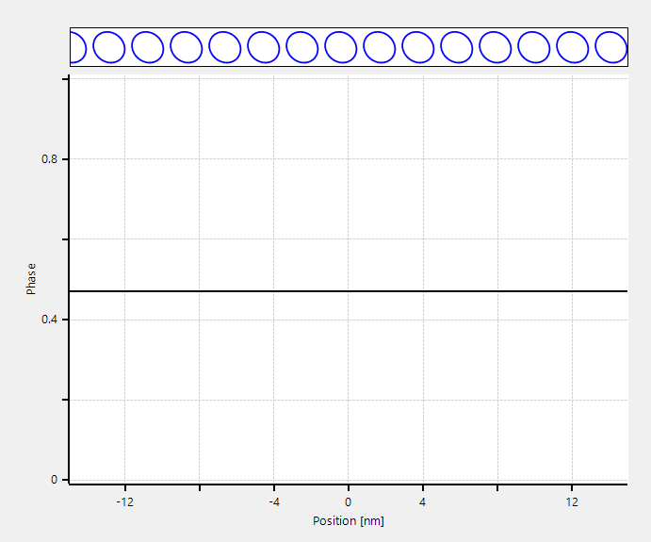

Figure : Eccentricity and Polarization Ellipse of Field After 1D Grating QWP

If this were an ideal quarter waveplate, we would expect the polarization of the light after the grating to be purely circular. However, as you can see from the plot of the eccentricity of the polarization in Figure 9, this is not exactly the case. It appears we have an eccentricity of ~.5 (circular polarization has an eccentricity of 0, linear polarization has an Eccentricity of 1) and looking at the polarization ellipse its clear that it is not circular. There are two obvious reasons that this might be the case. The first is that I am using an approximation for the TE and TM indices, which means the phase difference I was attempting to engineer might not be exactly what it should be. I can check this using the Phase Detector snippet I wrote, detailed in Section 7.1.1, which will tell me the simulated phase difference between the two modes. Running this, I get:



Figure : 1-Dimensional QWP Phase Difference

You can see that the true phase difference introduced is slightly less than the π/2 phase difference we were expecting. The second issue is that, because the indices in the TE and TM directions are different, their transmittances will be different. This difference can be demonstrated by running the polarization analyzer and checking the Ex and Ey efficiencies:



Figure : 1-Dimensional QWP Efficiencies

Since circular polarization requires equal power in each linear polarization mode, a quarter waveplate with unequal transmittance efficiencies can’t ever convert linearly polarized light to true circular polarization. Using the Phase Detector and Polarization Analyzer, I can attempt to optimize this 1-Dimensional Grating to be a true quarter waveplate with a Parametric Optimization. I’ll attempt to vary all of the parameters of the grating, and set the polarization contrast to 1 and the phase difference to π/2:

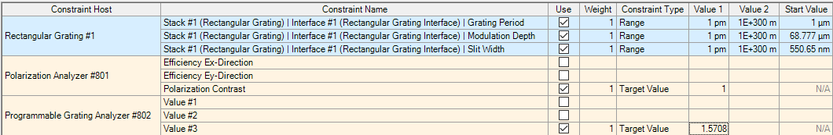

Figure : 1-Dimensional Grating QWP Optimization Parameters

Running this, I get the following:

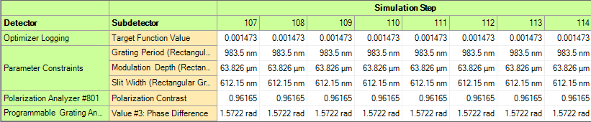

Figure : 1-Dimensional Grating QWP Parametric Optimization

Unfortunately, I was not able to simultaneously optimize these two parameters. I imagine this is due to these properties being inherently at odds, since different indices are needed to introduce any phase difference, but the different indices will lead to different transmittances. I can program these values into the grating to see what it gives me:

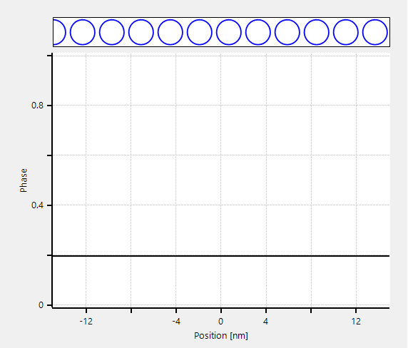

Figure : Optimized 1-Dimensional QWP Ellipticity

Even though I wasn’t able to achieve an ideal quarter waveplate, the simulated results still look much better than the results we obtained with the initial calculations, with an ellipticity of around .2 and a visibly circular polarization ellipse. I will attempt to resolve this non-ideality in subsequent sections by introducing more degrees of freedom to the grating structure. However, the grating we have designed has a very high aspect ratio and thus would likely be difficult to manufacture.

## Subwavelength Grating Half Waveplate

A quarter waveplate, as we saw in 3.2, a quarter waveplate will convert linear polarization to circular polarization by introducing a “Quarter Wave” of phase between the two polarization modes. If we introduce another quarter wave of phase delay between the two modes, we will be returned to a linearly polarized state, but one that has been rotated by 90°. Using the same analysis as for the quarter waveplate, we can determine that the necessary thickness to create a half waveplate will be:

As we demonstrated with the quarter waveplate, the first order design was much less accurate than the optimized design, so I will forgo the first order calculation here and simply attempt to optimize the rectangular grating we have been using to introduce a half wave of phase:

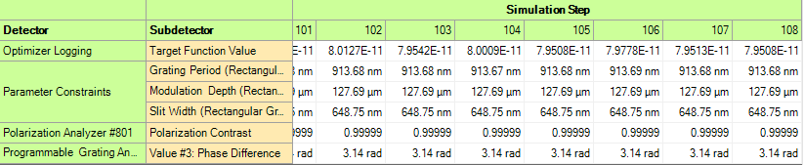

Figure : 1-Dimensional Grating Half Waveplate Parametric Optimization

It seems that the half waveplate is more suitable to this approach than the quarter waveplate, since we were able to get nearly ideal results with this optimization. I can now program these values into the grating and run the Classic Field Trace to get:

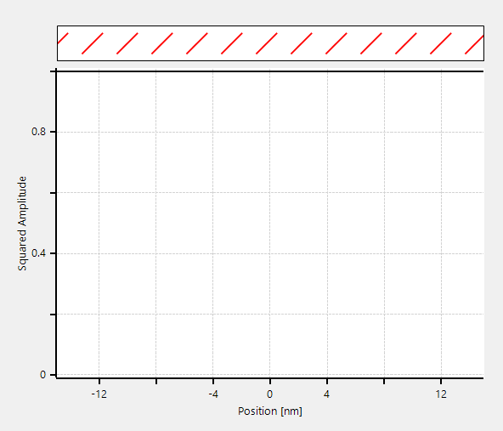

Figure : Optimized 1-Dimensional Grating HWP Results

As you can see, we get very nice results from this half waveplate. The eccentricity is very nearly 1, and the polarization ellipse appears to be essentially purely linear and at an angle of 90° to the input. However, as stated previously, the aspect ratio of this structure would likely make it difficult to fabricate, even more so than the QWP since it is around twice as thick at 127 µm.

# http://imagebank.osa.org/getImage.xqy?img=dTcqLmxhcmdlLGFvLTMzLTM0LTc4NzUtZzAwMg2-Dimensional Sub-Wavelength Gratings

Figure : 2-Dimensional Symmetric Binary Grating [2]

As we saw in the 1-Dimensional Subwavelength Grating section, the inherent anisotropy between the TE and TM mode allows us to fabricate structures like half and quarter waveplates, but kept us from designing a polarization independent AR coating. I’ll now analyze if and how introducing another degree of freedom to our grating will help compared to the 1-Dimensional case.

## 2-Dimensional Anti-Reflective Grating

While I was not able to find any effective medium theories that fully described the refractive indices of a general 2-Dimensional grating structure, I was able to find a model that predicts the index of a symmetric 2-Dimensional Grating, as shown in Figure 17, which due to its symmetry will have equal indices f or the TE and TM modes. For a structure of this form, with fill factors fx = fy = f, can construct two effective permittivities as:

Equation : Symmetric 2-Dimensional Grating Zeroth Order Permitivities [2]

Where the zeroth order TE and TM permittivities are defined in Equation 4. I said before that the symmetry will give us just a single refractive index, but there are two permittivities here. The actual effective permittivity will be the *average* of these two. The authors of this paper, though, provided an even better approximation, in their opinion, for the index:

Equation : Effective Index of Symmetric 2-Dimensional Grating [2]

Where is the average refractive index of the two media. Because a symmetric grating such as this will have just a single refractive index, I can use it to design a polarization independent AR coating, unlike in the 1-Dimensional case, which could only be made antireflective for a single polarization mode.

Using the effective index equation in Equation 10 and the AR coating parameters in Equation 5, I can very easily design a polarization independent AR coating. To do this, I again used [this](https://studentuncc-my.sharepoint.com/:x:/g/personal/mlata_uncc_edu/EcwIpuLhXlZMtJ_QikDI0hMBv5RaD9SCsOHOGHm6xgQyug?e=890Wvp) spreadsheet, finding the following design parameters for a wavelength of 25 and grating period of 1 :

I can use a Pillar Grating optical setup in VirtualLab to build this structure:

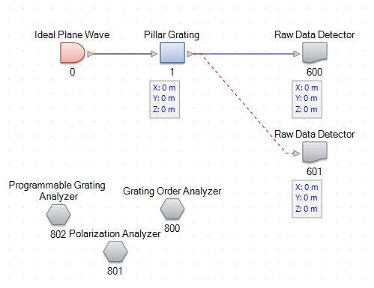

Figure : Pillar Grating Optical Setup

I can now program the pillar grating to have the desired dimensions:

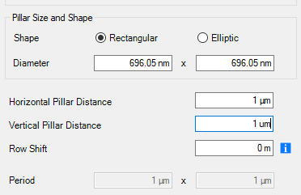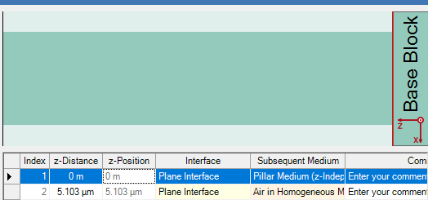

Figure : Pillar Grating AR Coating Parameters

Running the polarization analyzer on this gives me the following results:



So this indeed works fairly well as an AR coating! You can also see that the polarization contrast is 1, which tells us that this is in fact polarization independent as expected. I would like to now optimize this structure to act as a perfect AR coating in both directions, but I would also like to maintain the symmetry that we have established. Unfortunately, there’s no way that I am aware of to enforce that two independent parameters stay equal to one another in the course of an optimization routine. To get around this, I can use a programmable grating to build my own 2-Dimensional Grating structures that will remain symmetric. The code for this grating can be found in 7.1.2. I will implement this structure in a General Grating 3D Optical Setup:

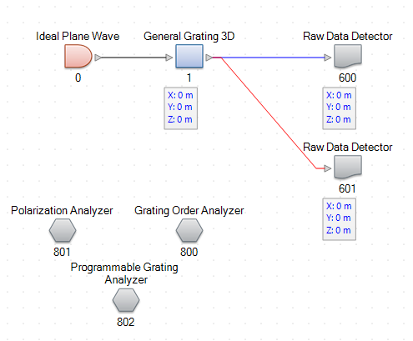

Figure : General Grating 3D Optical Setup

I’ll use the parameters determined before as the starting point from my parametric optimization, and vary only the fill factor and the height of the grating while attempting to make the TE and TM transmittances both 100%:

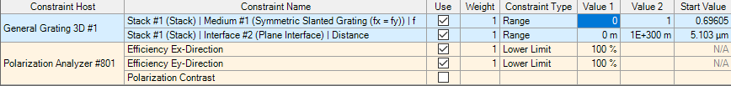

Figure : 2-Dimensional Symmetric AR Grating Parametric Optimization Parameters

Running this optimization quickly returns the following result:

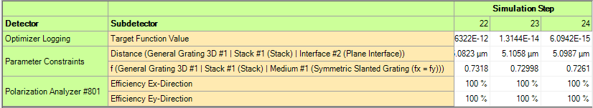

Figure : 2-Dimensional Symmetric AR Grating Optimization Results

Programming the grating with these optimized parameters and running the polarization analyzer confirms these results:



You can see that we have 100% transmittance in both polarization modes, which can be contrasted against the grating designed in section 3.1, which was only truly antireflective for the TE mode.

## 2-Dimensional Grating Quarter Waveplate

Having established the infrastructure to optimize for the phase difference between the TE and TM modes transmitted through a grating, and also having established the framework to optimize 2-Dimensional gratings, I can now attempt to design and optimize a Quarter Waveplate using a 2-Dimensional grating. You’ll remember from Section 3.2 that we were not able to design an ideal QWP using a 1-Dimensional grating, so I’m hopeful the added degree of freedom of the 2-Dimensional grating will make this possible. Since a symmetric 2-Dimensional grating will have equal indices for the TE and TM mode, we cannot use a symmetric grating to design a waveplate. So I will return to the Pillar Grating Optical Setup from the initial AR grating design to attempt this design. It’s worth noting that the Index contrast is highest for the 1-Dimensional Grating, so I would expect any waveplates designed with a two dimensional grating will need to be much thicker than the 1-Dimensional case. I will allow all of the grating parameters to vary while attempting to keep the Polarization Contrast equal to 1 and setting the Phase Difference to π/2:

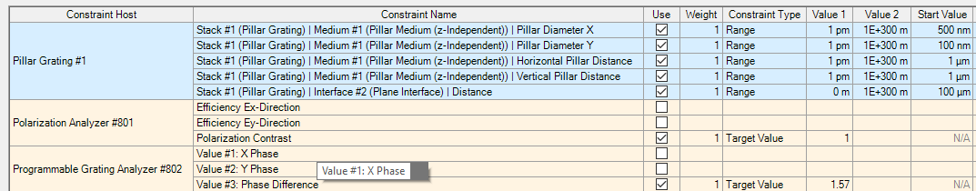

Figure : 2-Dimensional QWP Grating Optimization Parameters

Running this parametric optimization gives me the following results:

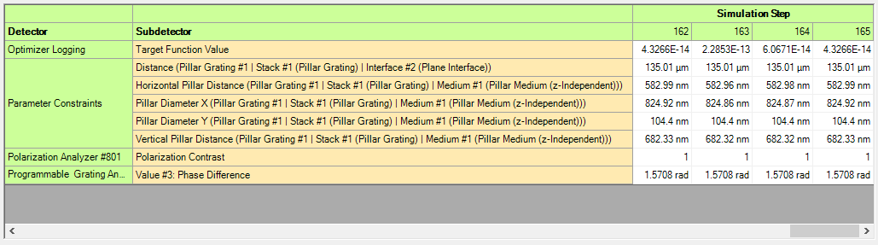  
Figure : 2-Dimensional Grating QWP Optimized Parameters

So it appears we are indeed able to achieve an ideal quarter waveplate in the 2-Dimensional case. You’ll notice, however, that the X Pillar Diameter is *greater* than the X Pillar Distance, which means this may not be the style of grating that we were expecting! Programming these parameters and looking at the index distribution, I find that we have something that looks like:

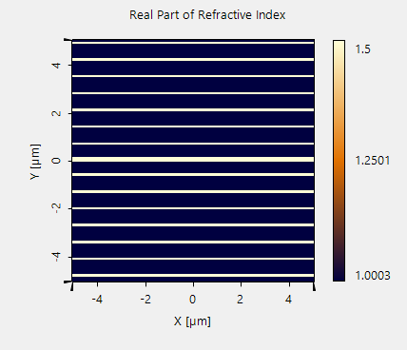

Figure : Ideal QWP Grating

So even this 2-Dimensional grating, when attempting to optimize for a phase difference between the two modes, will naturally regress to a 1-Dimensional grating since, as I said previously, the index contrast is highest for a 1-Dimensional grating. There is a small subtlety however, which is that this is not a uniform 1-Dimensional Grating since some of the grating ridges are slightly wider than others. Adding the additional degree of freedom has allowed us, rather than creating a 2-Dimensionakl grating in the form I was expecting, to create a 1-Dimensional grating with variations in the feature width. You will also notice that this is, again, a very high aspect ratio grating, with a height of 135 µm, which would make it difficult to fabricate. I can program these parameters into my grating and run the Classic Field Tracing simulation to confirm that this is working as we expect:

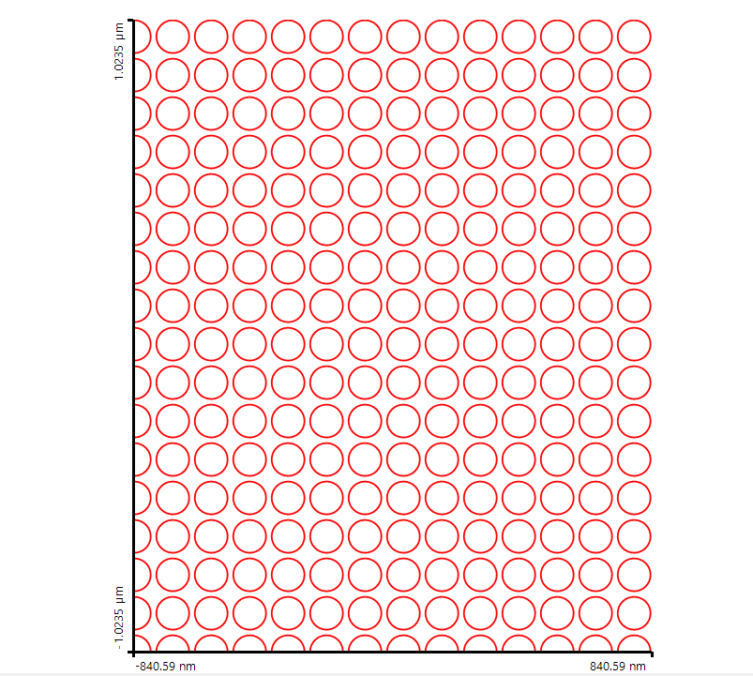

Figure : 2-Dimensional QWP Response

You can see the output polarization ellipse after sending in equal intensity to each mode appears very circular. Checking the ellipticity confirms that we now have an ellipticity of 0, which is exactly what we expect for pure circular polarization!

## 2-Dimensional Grating Half Waveplate

I can once again use this same process to design a half waveplate. While the 1-Dimensiona HWP we found in section 3.3 was already ideal, it was also extremely thick. It’s possible the 2-Dimensional grating could achieve the same performance in a more efficient way. I can set up the same optimization as before but now attempting to introduce π radians of phase rather than π/2 radians:

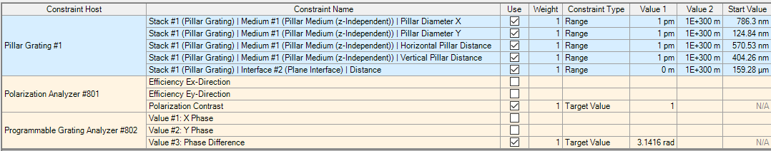

Figure : 2-Dimensional HWP Grating Optimization Parameters

Doing this I get the following results:

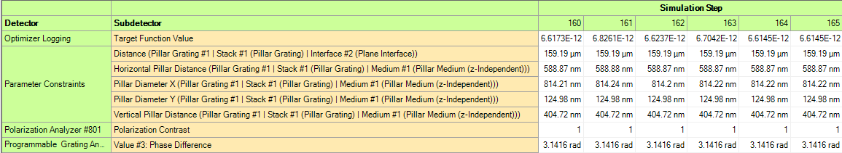

Figure : 2-Dimensional HWP Grating Optimization Results

We have once again achieved an ideal response, and you’ll also notice that our grating has regressed from a purely 2-Dimensional grating to a 1-Dimensional grating with variation in the groove width. Programming these parameters into the grating and looking at the distribution demonstrates this:

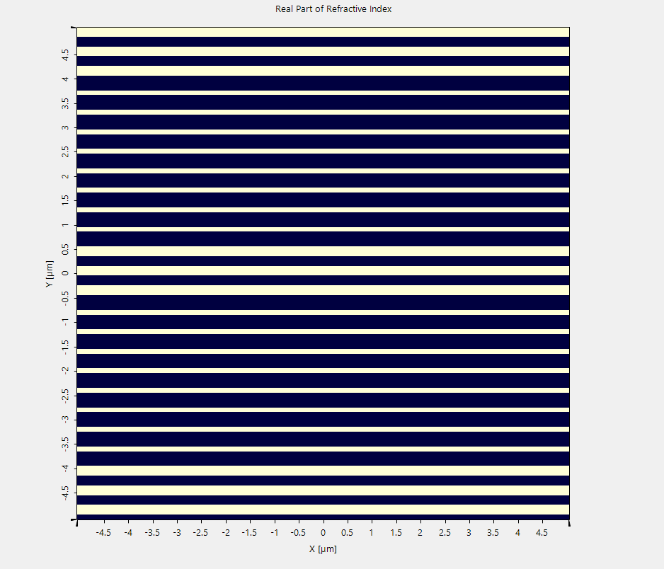

Figure : 2-Dimensional HWP Grating Profile

You can see we obtain a 1-Dimensional grating with fluctuating ridge width rather than a true 2-Dimensional grating, similar to the Optimized HWP. If I now run a Classic Field Trace on this grating with equal power in the TE and TM modes, I get the following result:

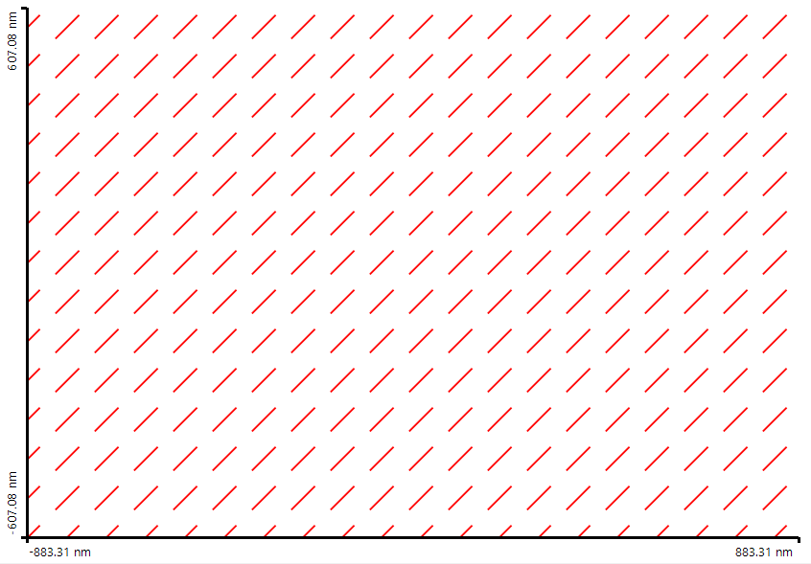

Figure : Optimized 2-Dimensional HWP Results

Once again, we get the expected linear polarization rotated at 45° with respect to the input polarization. It’s worth noting, though, that this grating is 159 µm thick compared to the 127 µm that it took to achieve this with the 1-Dimensional HWP. This suggests that, contrary to my expectation, the 1-Dimensional grating is in fact more efficient for creating a HWP than the 2-Dimensional case.

# Slanted Gratings

Now that we have explored the polarizing properties and some of the applications of 1- and 2-Dimensional Subwavelength Gratings, I would now like to investigate the properties of the slanted wire structures introduced in Section 2. These slanted wire structures resemble the traditional 2-Dimensional gratings we’ve been looking at that have been slanted at a given angle. This can also be done however with the 1-Dimensional grating, which is a functionality that is included in the VirtualLab Grating toolbox due to their common use of coupling light into waveguides [7]. Before I look at the 2-Dimensional Slanted Wire case, I’ll fist look at the 1-Dimensional case in hopes that it will illuminate the 2-Dimensional case further.

## 1-DIMENSIONAL SLANTED SUB-WAVELENGTH GRATINGS

Figure : 1-Dimensional Slanted Grating

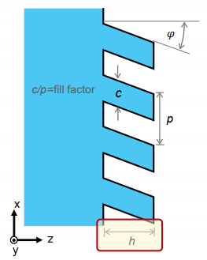I am hoping to understand the effect that slanting the grating has on its optical properties. My intuition is that these gratings act as anisotropic crystal-like layers, so from that perspective slanting the grating will be effectively like rotating an anisotropic crystal. I know that if I have a uniaxial crystal and a wave incident at some angle θ to the crystal’s optical axis, the wave will experience two refractive indexes given by:

Equation : Refractive Indexes of Uniaxial Crystal [1]

Where no is the ordinary refractive index that is experienced when light is traveling along the optical axis and n­e is the extraordinary refractive index, which is experienced by light whose field is parallel to the optical axis. To test my theory that slanting the wires will be analogous to rotating a uniaxial crystal, I can run a very simple simulation in VirtualLab to test the index that is experienced by each polarization mode of the light passing through the slanted grating.

To test the index that each polarization mode experiences, I will make a thin slanted grating layer and measure the phase of each mode after passing through the slanted grating layer using my Phase Detector snippet. I know that the phase introduced by a thin layer of thickness d should be of the form:

Using this equation, I can solve for the index in terms of the thickness of the layer, the wavelength, and the phase:

Equation : Index of Refraction from Phase

I can perform this calculation for a range of slant angles, then compare the results to the uniaxial crystal model of Equation 11.

To begin, I’ll open up a Slanted Wire Optical Setup in VirtualLab:

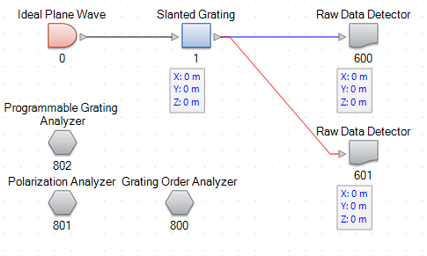

Figure : Slanted Grating Optical Setup

I will now establish the parameters of the grating. I will continue to use a material of index 1.5, and use a fill factor of 50% and thickness of 1 µm:

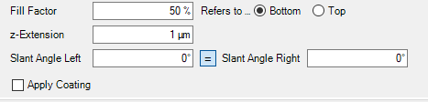

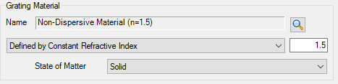

Figure : Slanted Grating Parameters

You’ll also notice that I am setting the left and right slant angles to be equal. To get the data I need to perform this analysis, I will perform a parameter run on this slanted grating that measures the phase of each polarization mode while varying the slant angle:



Figure : Slanted Grating Parameter Run Settings

Performing this parameter run gives me the following results:

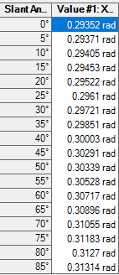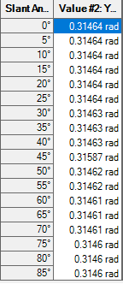

Figure : Slanted Grating Parameter Run Results

Using [this](https://studentuncc-my.sharepoint.com/:x:/g/personal/mlata_uncc_edu/EcwIpuLhXlZMtJ_QikDI0hMBv5RaD9SCsOHOGHm6xgQyug?e=890Wvp) spreadsheet, I can calculate the index that each of these phases correspond to as well as index predicted by the uniaxial crystal model. Plotting these vs. the slant angle gives:

Figure : Plot of Slanted Grating Indexes vs. Slant Angle

You can see that as the slant angle increases, the x index, which is in the direction of the slant angle, gradually increases, while the y index, which is normal to the slant of the grating, stays essentially fixed. The two directions also converge to the same index, which is to be expected since as the slant angle goes to 90°, the grating is getting closer to a just flat surface. The model of Equation 11 appears to fit the simulated index quite nicely, which suggests that the theory that slanting a subwavelength grating can be conceived of as rotating a uniaxial crystal might be a valid one

Since the index contrast is greatest for a slant angle of 0°, this slanted angle grating does not appear to be as useful for designing waveplates as the unslanted grating. I could use it design AR coatings, and perhaps even find a combination of slant angle and fill factor that gives near perfect transmittance for both TE and TM modes, however, since the index of each mode will never be equal for a slanted grating, it will never be able to achieve as good of results as the 2-Dimensional grating designed in Section 4.1.

## Slanted 2-Dimensional Sub-Wavelength Gratings

I would now like to perform this same analysis on a Slanted Wire grating to determine of it can also be viewed from this rotated crystal perspective. Unfortunately, VirtualLab does not have a built in Slanted Wire structure, so I am forced to build my own! The code for this can be found in Section 7.1.3. I can implement this slanted wire grating in a General Grating 3D Optical Setup:

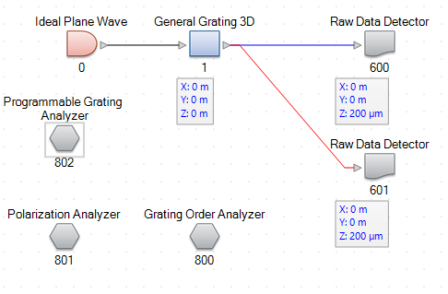

Figure : General Grating 3D Optical Setup

I can program the grating to have a 1 µm period and 50% fill factor in both x and y directions:

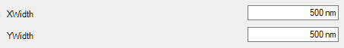

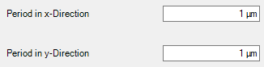

Figure : Slanted Wire Grating Parameters

I will give also give the grating a thickness of 1 µm. I can look at the index distribution to confirm that the slanting works as expected:

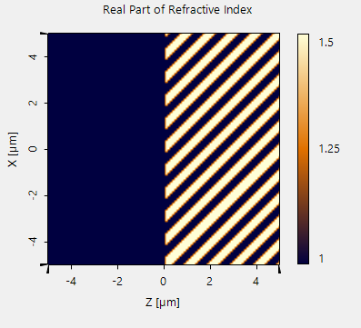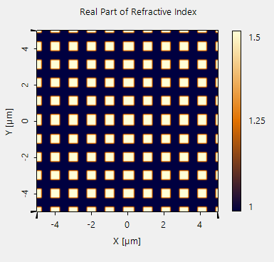

Figure : Slanted Wire Grating Created with Snippet

These indeed look like the slanted wires that I am expecting. Performing the same procedure as for the slanted grating, I get the following results:

Figure : Refractive Index of Slanted Wire Grating vs. Slant Angle

Once again, the crystal model fits very nicely to the results. However, you’ll notice that now, rather than the y index remaining fixed, it is the x index that remains fixed while the y index increases. The slant angle for both the 1-D and 2-D gratings is in the x direction, so why does this happen? Both the 1-D and 2-D cases act as rotating uniaxial crystals, but in the 1-Dimensional case, we are starting at an angle of incidence normal to the optical axis, giving us a maximum index contrast between the two modes, and as the grating slants, we get closer and closer to propagating parallel to the optical axis. The index of the modes converge at this point to the ordinary index, which is greater than extraordinary index, making this a negative uniaxial crystal. In the 2-Dimensional case, we start aligned with the optical axis with both modes propagating at the Ordinary index, and as the wires slant we get closer and closer to propagating perpendicular to the optical axis (eventually becoming a 1-dimensional grating in the 90° limit) where there is the maximum index contrast. In this case the Extraordinary index is greater than the Ordinary index, making it a positive uniaxial crystal. The reason that y remains fixed in the first and x remains fixed in the second is because y in both cases represents the TE mode, which, in the 1-Dimensional grating limit, has a higher index than the TM mode. The y index should always be greater than the x index, then, and the reason they swap between the two is that one acts as a negative crystal and the other acts as a positive crystal.

While it is interesting that I have managed to fit a fairly reasonable model to these slanted wire structures, the very low index contrast, even at extreme slanting angles, and relatively small index in both modes suggests this structure, similar to the slanted grating, is ill suited compared to the unslanted gratings for creating waveplates or AR coatings.

# Conclusions

After a thorough analysis of the polarizing properties of subwavelength grating structures, it seems apparent that introducing a slant to these gratings does not appear to offer any meaningful advantages for the purposes of designing polarizing optics.

I was able to design a TE antireflective coating using a 1-Dimensional grating, and a polarization independent AR coating using a symmetric 2-Dimensional grating.

I was also able to show that ideal and near-ideal Quarter and Half waveplates can be constructed from subwavelength gratings. While I was able to achieve an ideal quarter waveplate using just a 1-Dimensional grating, I needed to introduce additional degrees of freedom to achieve an ideal quarter waveplate. While I expected the 2-Dimensional gratings to maintain the “pillar” form factor, in both 2-D waveplate designs they degenerated to 1-D gratings with varying groove widths.

Based on the observation that a symmetric 2-Dimensional grating acts as a uniaxial grating, I postulated that a slanted wire grating would act similarly to a rotated uniaxial crystal. By using a thin slanted grating film and a phase detector I was able to demonstrate that this is indeed the case, with the 1-Dimensional grating acting like a negative uniaxial crystal and the 2-Dimensional grating acting like positive uniaxial crystal.

Unfortunately, it seemed apparent based on these investigations that adding the slant angle to the gratings was not going to aid in the design of either the waveplate or AR gratings. The 1-Dimensional grating has the highest index contrast of all structures studied, making it the most suitable for waveplate designs, though a modified 1-D grating is required to achieve the equal mode transmittance required for ideal waveplates. And the Symmetric 2-Dimensional grating, having equal indexes for each mode, is the best suited for designing polarization independent AR gratings.

While these slanted grating structures did not prove useful for any of the optics I was designing here, I was able to achieve a better understanding of the response I should expect from such a structure. Based on the results of the 2-Dimensional waveplates, I believe that a potentially more useful structure would be a more complex 1-Dimensional with a more finely structure unit cell, in the vein of a Damman grating.

# Appendix

## Snippets

### Phase Detector

DetectorResultObject[] detectorResults = new DetectorResultObject[3];

double xPhase;

double yPhase;

double phaseDifference;

double xEff;

double yEff;

ComplexAmplitude[] TransmissionNearField = new ComplexAmplitude[1];

TransmissionNearField[0] = VirtualLabAPI.Core.FieldRepresentations.RigorousSimulationResult1D.ConvertRigorousSimulationResultToNearField(TransmissionResults, 1, 3, true, true, true);

xPhase = TransmissionNearField[0].FieldX[0, 0].Arg();

yPhase = TransmissionNearField[0].FieldY[0, 0].Arg();

phaseDifference = Math.Abs(xPhase - yPhase);

if (phaseDifference >= Math.PI)

phaseDifference = phaseDifference - Math.PI;

xEff = TransmissionResults.GetOrder(0,0).Efficiency;

yEff = TransmissionResults.GetOrder(0,0).RayleighCoefficients.Y.Abs();

detectorResults[0] = new DetectorResultObject(new PhysicalValue(xPhase,PhysicalProperty.AngleRad,"X Phase"), "My Detector");

detectorResults[1] = new DetectorResultObject(new PhysicalValue(yPhase,PhysicalProperty.AngleRad, "Y Phase"), "My Detector");

detectorResults[2] = new DetectorResultObject(new PhysicalValue(phaseDifference,PhysicalProperty.AngleRad, "Phase Difference"), "My Detector");

return detectorResults;

### Symmetric 2-Dimensional Grating

double realPart = 1.0;

double imaginaryPart = 0.0;

double slope = Math.Tan(SlantAngle);

int wireCountX = 0;

int wireCountY = 0;

double xp = x*Math.Cos(theta) + y*Math.Sin(theta);

double yp = -x*Math.Sin(theta) + y*Math.Cos(theta);

for(int i = -wireCountX; i <= wireCountX; i++)

for(int j = -wireCountY; j <= wireCountY; j++)

if (xp + f*MediaPeriodX / 2 >= slope*z + i*MediaPeriodX && xp - f*MediaPeriodX / 2 <= slope*z + i*MediaPeriodX && yp+f*MediaPeriodY/2 >= j*MediaPeriodY && yp-f*MediaPeriodY / 2 <= j*MediaPeriodY && z>=0)

realPart = Index;

return new Complex(realPart, imaginaryPart);

### Slanted Wires Grating

double realPart = 1.0;

double imaginaryPart = 0.0;

double slope = Math.Tan(SlantAngle);

int wireCountX = 250;

int wireCountY = 250;

double xp = x*Math.Cos(theta) + y*Math.Sin(theta);

double yp = -x*Math.Sin(theta) + y*Math.Cos(theta);

for(int i = -wireCountX; i <= wireCountX; i++)

for(int j = -wireCountY; j <= wireCountY; j++)

if (xp + XWidth / 2 >= slope*z + i*MediaPeriodX && xp - XWidth / 2 <= slope*z + i*MediaPeriodX && yp+YWidth/2 >= j*MediaPeriodY && yp-YWidth / 2 <= j*MediaPeriodY && z>=0)

realPart = Index;

return new Complex(realPart, imaginaryPart);

# Works Cited

1. *Birefringence*. Available from: <https://en.wikipedia.org/wiki/Birefringence>.

2. Bräuer, R. and O. Bryngdahl, *Design of antireflection gratings with approximate and rigorous methods.* Applied Optics, 1994. **33**(34): p. 7875-7882.

3. Pajewski, L., et al., *Design of a binary grating with subwavelength features that acts as a polarizing beam splitter.* Applied Optics, 2001. **40**(32): p. 5898-5905.

4. *Polarization (waves)*. Available from: <https://en.wikipedia.org/wiki/Polarization_(waves)#Transverse_electromagnetic_waves>.

5. Rumpf, R.C. *Subwavelength Gratings*. 21st Centuryu Electromagnetics 2016; Available from: <http://emlab.utep.edu/ee5390em21/Lecture%2010%20--%20Subwavelength%20gratings.pdf>.

6. Suleski, T., *Thin Films and Subwavelength Optics*.

7. *Analysis of Slanted Gratings for Lightguide Coupling*. Available from: <https://www.lighttrans.com/use-cases/application-use-cases/analysis-of-slanted-gratings-for-lightguide-coupling.html>.